A

Mini Project On

#### SUPERMARKET BILLING SYSTEM USING WEBCAM

(Submitted in partial fulfilment of the requirements for the award of Degree)

BACHELOR OF TECHNOLOGY

In

COMPUTER SCIENCE AND ENGINEERING

By

SHAIK MOHAMMED ALTAF (217R5A0522) AMMANNAGARI VIDHATHRI (207R1A05J6)

MADDELA ANUROOP (217R5A0520)

Under the Guidance of

**A. GANAPATHI**

(Assistant Professor)

##### DEPARTMENT OF COMPUTER SCIENCE AND ENGINEERING

**CMR TECHNICAL CAMPUS UGC AUTONOMOUS**

(Accredited by NAAC, NBA, Permanently Affiliated to JNTUH, approved by AICTE, New Delhi) Recognized Under Section 2(f) & 12(B) of the UGCAct.1956, Kandlakoya (V),

Medchal Road, Hyderabad-501401.

**2020-2024**

**DEPARTMENT OF COMPUTER SCIENCE AND ENGINEERING**



#### CERTIFICATE

This is to certify that the project entitled **“SUPERMARKET BILLING SYSTEM USING WEBCAM”** being submitted by **SHAIK MOHAMMED ALTAF(217R5A0522),**

**A.VIDHATHRI(207R1A05J6) & M.ANUROOP(217R5A0520)** in partial fulfilment of the requirements for the award of the degree of B.Tech in Computer Science and Engineering to the Jawaharlal Nehru Technological University Hyderabad, is a record of Bonafide work carried out by them under our guidance and supervision during the year 2023-24.

The results embodied in this thesis have not been submitted to any other University Institute for the award of any degree or diploma.

|  |  |
| --- | --- |
| **A. GANAPATHI** | **Dr. A. Raji Reddy** |
| (Assistant Professor) INTERNAL GUIDE | DIRECTOR |
| **Dr. K. Srujan Raju**  HOD | **EXTERNAL EXAMINER** |

**Submitted for viva voice Examination held on**

##### ACKNOWLEDGEMENT

Apart from the efforts of us, the success of any project depends largely on the encouragement and guidelines of many others. We take this opportunity to express our gratitude to the people who have been instrumental in the successful completion of this project.

We take this opportunity to express my profound gratitude and deep regard to my guide **A. GANAPATHI,** Assistant Professor for his exemplary guidance, monitoring and constant encouragement throughout the project work. The blessing, help and guidance given by him shall carry us a long way in the journey of life on which we are about to embark.

We also take this opportunity to express a deep sense of gratitude to the Project Review Committee (PRC) **G.Vinesh Shanker, Dr. J. Narasimharao, Ms. Shilpa, & Dr. K. Maheswari** for their cordial support, valuable information and guidance, which helped us in completing this task through various stages.

We are also thankful to **Dr. K. Srujan Raju,** Head, Department of Computer Science and Engineering for providing encouragement and support for completing this project successfully.

We are obliged to **Dr. A. Raji Reddy,** Director for being cooperative throughout the course of this project. We also express our sincere gratitude to Sri. **Ch. Gopal Reddy,** Chairman for providing excellent infrastructure and a nice atmosphere throughout the course of this project.

The guidance and support received from all the members of **CMR Technical Campus** who contributed to the completion of the project. We are grateful for their constant support and help.

Finally, we would like to take this opportunity to thank our family for their constant encouragement, without which this assignment would not be completed. We sincerely acknowledge and thank all those who gave support directly and indirectly in the completion of this project.

**SHAIK MOHAMMED ALTAF (217R5A0522) AMMANNAGARI VIDHATHRI (207R1A05J6) MADDELA ANUROOP (217R5A0520)**

#### ABSTRACT

The Supermarket Billing System Using Webcam is an innovative approach to streamline the checkout process in supermarkets. This system leverages webcam technology to enhance the speed and accuracy of the billing process, improving the overall shopping experience for customers and efficiency for supermarket operators.

Traditionally, supermarket checkout involves manually scanning each product's barcode, which can be time-consuming and error prone. The proposed system utilizes webcam technology to capture product information through image recognition and barcode scanning. This not only accelerates the checkout process but also reduces the need for dedicated barcode scanners, leading to cost savings.

Key features of the Supermarket Billing System Using Webcam include real-time product recognition, automatic price retrieval from a central database, and secure payment processing. Furthermore, it offers the convenience of digital receipts, making it environmentally friendly and providing customers with a digital record of their purchases.

This system aims to improve customer satisfaction by reducing wait times at checkout, minimizing errors in billing, and enhancing overall shopping convenience. Additionally, it offers supermarkets valuable insights into inventory management and sales trends through data analytics.

### LIST OF FIGURES/TABLES

#### FIGURE NO. FIGURE NAME PAGE NO.

Figure 3.1 Project Architecture of Supermarket 7

Billing system using webcam

|  |  |  |
| --- | --- | --- |
| Figure 3.2 | Use Case Diagram of Supermarket Billing system using webcam | 8 |
| Figure 3.3 | Class Diagram of Supermarket Billing system using webcam | 9 |
| Figure 3.4 | Sequence diagram of Supermarket Billing system using webcam | 10 |
| Figure 3.5 | Activity diagram of Supermarket Billing system using webcam | 11 |

### LIST OF SCREENSHOTS

**SCREENSHOT NO. SCREENSHOT NAME PAGE NO.**

|  |  |  |
| --- | --- | --- |
| Screenshot 5.1 | Product Folder is Created to store | 22 |
|  | images of the product |  |
| Screenshot 5.2 | Front and Back of the product is | 22 |
|  | Captured and Stored |  |
| Screenshot 5.3  Screenshot 5.4 | Application are Connected to webcam and model is trained  Accuracy of the trained model  is displayed | 23  23 |
| Screenshot 5.5 | Product is shown to the webcam | 24 |
| Screenshot 5.6 | Product information is displayed | 24 |
| Screenshot 5.7 | Showing another product to the webcam | 25 |
| Screenshot 5.8 | Product name and cost is displayed for both products | 26 |

### TABLE OF CONTENTS

|  |  |
| --- | --- |
| **ABSTRACT** | i |
| **LIST OF FIGURES** | ii |
| **LIST OF SCREENSHOTS** | iii |
| **1.INTRODUCTION** | 1 |
| 1.1 PROJECT SCOPE | 1 |
| 1.2 PROJECT PURPOSE | 1 |
| 1.3 PROJECT FEATURES | 1 |
| **2.SYSTEM ANALYSIS** | 2 |
| 2.1 PROBLEM DEFINITION | 2 |
| 2.2 EXISTING SYSTEM | 2 |
| 2.2.1 DISADVANTAGES OF THE EXISTING SYSTEM | 3 |
| 2.3 PROPOSED SYSTEM | 3 |
| 2.3.1 ADVANTAGES OF PROPOSED SYSTEM | 3 |
| 2.4 FEASIBILITY STUDY | 4 |
| 2.4.1 ECONOMIC FEASIBILITY | 4 |
| 2.4.2 TECHNICAL FEASIBILITY | 5 |
| 2.4.3 SOCIAL FEASIBILITY | 5 |
| 2.5 HARDWARE & SOFTWARE REQUIREMENTS | 5 |
| 2.5.1 HARDWARE REQUIREMENTS | 5 |
| 2.5.2 SOFTWARE REQUIREMENTS | 6 |
| **3.ARCHITECTURE** | 7 |
| 3.1 PROJECT ARCHITECTURE | 7 |
| 3.2 DESCRIPTION | 7 |
| 3.3 USE CASE DIAGRAM | 8 |
| 3.4 CLASS DIAGRAM | 9 |
| 3.5 SEQUENCE DIAGRAM | 10 |
| 3.6 ACTIVITY DIAGRAM | 11 |

1. IMPLEMENTATION 12
   1. SAMPLE CODE 12
2. SCREENSHOTS 22
3. TESTING 27
   1. INTRODUCTION TO TESTING 27
   2. TYPES OF TESTING 27

|  |  |
| --- | --- |
| 6.2.1 UNIT TESTING | 27 |
| 6.2.2 INTEGRATION TESTING | 28 |
| 6.2.3 FUNCTIONAL TESTING | 28 |
| 6.3 TEST CASES | 29 |
| 6.3.1 CLASSIFICATION | 29 |
| **7. CONCLUSION & FUTURE SCOPE** | 30 |
| 7.1 PROJECT CONCLUSION | 30 |
| 7.2 FUTURE SCOPE | 30 |
| **8. REFERENCES** | 31 |
| 8.1 REFERENCES | 31 |
| 8.2 GITHUB LINK | 31 |

1. **INTRODUCTION**

### INTRODUCTION

##### PROJECT SCOPE

This project is titled “Supermarket billing system using webcam”. It entails the development of an advanced checkout solution for supermarkets, harnessing webcam technology to enhance efficiency and customer satisfaction. This system will incorporate several key features, including webcam-based product recognition, barcode scanning, real- time price retrieval from a central database, secure payment processing, and the generation of digital receipts. Furthermore, it will encompass inventory management capabilities, sales analytics tools, user authentication mechanisms, and an admin panel for supermarket management.

##### PROJECT PURPOSE

The purpose of a supermarket billing system using a webcam is to streamline the checkout process and improve efficiency in a supermarket or retail environment, it aims to improve the overall shopping experience, reduce operational costs, and provide valuable data for business optimization. It leverages technology to enhance efficiency and customer satisfaction in the retail environment.

##### PROJECT FEATURES

The main features of this project are to ensure security, user authentication algorithms verify the identity of cashiers during login, while access control algorithms manage permissions and restrict unauthorized actions within the system.Security algorithms incorporate encryption, access logging, and anomaly detection to protect against theft and fraud.These algorithms collectively form the backbone of the supermarket billing system, orchestrating the various features to deliver an automated, secure, and customer-friendly checkout process.

# SYSTEM ANALYSIS

### 2.SYSTEM ANALYSIS

##### SYSTEM ANALYSIS

System Analysis is the important phase in the system development process. The System is studied to the minute details and analyzed. The system analyst plays an important role of an interrogator and dwells deep into the working of the present system. In analysis, a detailed study of these operations performed by the system and their relationships within and outside the system is done. A key question considered here is, “what must be done to solve the problem?” The system is viewed as a whole and the inputs to the system are identified. Once analysis is completed the analyst has a firm understanding of what is to be done.

##### PROBLEM DEFINITION

To develop a software solution that can accurately and efficiently scan the items in a customer's shopping cart using the webcam, recognize the products, retrieve their prices from a database, calculate the bill, and generate an itemized receipt.

##### EXISTING SYSTEM

When the customer puts any product in the trolley its code is detected and the price of those products stored in the server, as we put the product the cost gets added to the final tally. The product name and its cost is displayed on the LCD. At the cashiers counter, the total bill is transferred by wireless radio frequency module. The limitation of this project is that after completion of purchases a button is pressed indicating the final list of all the products. After pressing the key can’t add or remove the products. Moreover, after all the shopping, the customer still has to go to the cashier’s counter to pay.

###### DISADVANTAGES OF EXISTING SYSTEM

Following are the disadvantages of existing system:

* + - * Longer queues requires more time.
      * Huge storage requirements.
      * Multiple products cannot be added or removed.

##### PROPOSED SYSTEM

The proposed system is a more feasible and elegant solution since it incorporates the preexisting bar code for each product into the billing mechanism thereby not using any external components like RFID tags. Furthermore, there are two additional security features in the form of weight sensing and image processing. As we put the products, the costs will get added to the total bill. Thus the billing will be done in the trolley itself hence it is an improvement from the previously mentioned paper.

###### ADVANTAGES OF THE PROPOSED SYSTEM

* Each and every product is stored in the system.
* Better customer experience.
* Reduces labour cost.

##### FEASIBILITY STUDY

The feasibility of the project is analysed in this phase and a business proposal is put forth with a very general plan for the project and some cost estimates. During system analysis, the feasibility study of the proposed system is to be carried out. This is to ensure that the proposed system is not a burden to the company. Three key considerations involved in the feasibility analysis:

1. Economic Feasibility
2. Technical Feasibility
3. Social Feasibility

###### ECONOMIC FEASIBILITY

The developing system must be justified by cost and benefit. Criteria to ensure that effort is concentrated on a project, which will give best, return at the earliest. One of the factors, which affect the development of a new system, is the cost it would require.

The following are some of the important financial questions asked during preliminary investigation:

* + - * The costs conduct a full system investigation.
      * The cost of the hardware and software.
      * The benefits in the form of reduced costs or fewer costly errors.

Since the system is developed as part of project work, there is no manual cost to spend for the proposed system. Also all the resources are already available, it give an indication that the system is economically possible for development.

###### TECHNICAL FEASIBILITY

This study is carried out to check the technical feasibility, that is, the technical requirements of the system. Any system developed must not have a high demand on the available technical resources. The developed system must have a modest requirement; as only minimal or null changes are required for implementing this system.

###### SOCIAL FEASIBILITY

This includes the following questions:

1. Is there sufficient support for the users?
2. Will the proposed system cause harm?

The project would be beneficial because it satisfies the objectives when developed and installed. All behavioral aspects are considered carefully and conclude that the project is behaviorally feasible

##### HARDWARE & SOFTWARE REQUIREMENTS

* + 1. **HARDWARE REQUIREMENTS:**

Hardware interfaces specify the logical characteristics of each interface between the software product and the hardware components of the system. The following are some hardware requirements.

* Processor : Intel Dual Core I5 and above
* Hard disk : 8GB and above
* RAM : 8GB and above
* Input devices : Keyboard, mouse.

##### SOFTWARE REQUIREMENTS:

Software Requirements specifies the logical characteristics of each interface and software components of the system. The following are some software requirements,

* Operating system : Windows 8 and above
* Languages : Python, Html, CSS
* Tools : Python IDEL3.7 version,PyCharm, Anaconda - Jupyter, Spyder

# ARCHITECTURE

##### ARCHITECTURE

* 1. **PROJECT ARCHITECTURE**

This project architecture shows the procedure followed for classification, starting from input to final prediction.

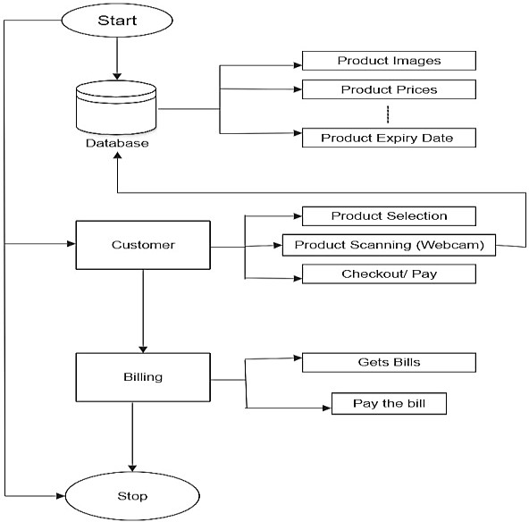

Figure 3.1: Project Architecture of Supermarket Billing system using webcam

###### DESCRIPTION

This project is totally based upon identifying the products and generating bill. The model is built to recognize the products and retrieves their prices from a database. Then, it calculates the total bill and generates a receipt. The model is built with libraries like pyttsx, os, opencv, pandas, numpy etc. Each library is used for a specific purpose.

###### USE CASE DIAGRAM

In the use case diagram, we have basically one actor who is the user in the trained model. A use case diagram is a graphical depiction of a user's possible interactions with a system.A use case diagram shows various use cases and different types of users the system has. The use cases are represented by either circles or ellipses. The actors are often shown as stick figures.

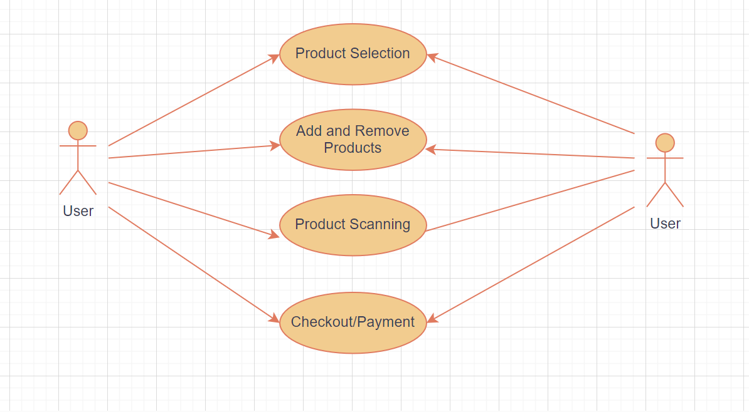

Figure 3.2: Use Case Diagram of Supermarket billing system using webcam

##### CLASS DIAGRAM

Class diagram is a type of static structure diagram that describes the structure of a system by showing the system’s classes, their attributes, operations (or methods), and the relationships among objects.

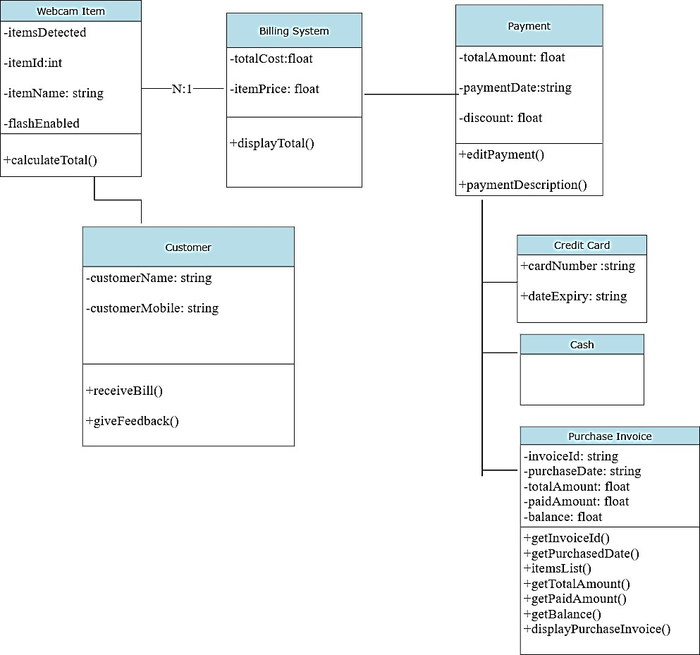

Figure 3.3: Class Diagram of Supermarket billing system using webcam

##### SEQUENCE DIAGRAM

A sequence diagram shows object interactions arranged in time sequence. It depicts the objects involved in the scenario and the sequence of messages exchanged between the objects needed to carry out the functionality of the scenario. Sequence diagrams are typically associated with use case realizations in the logical view of the system under development.

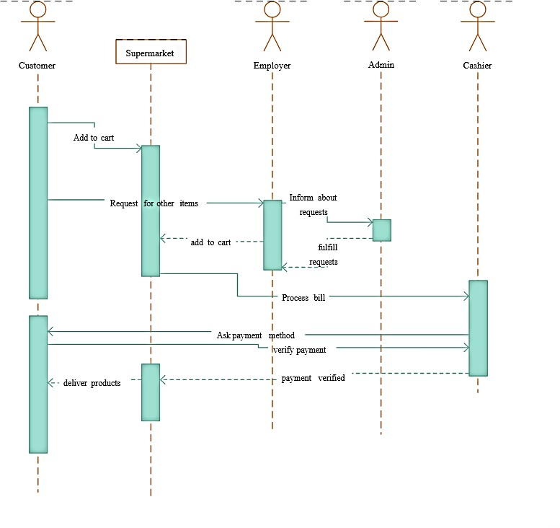

Figure 3.4: Sequence Diagram of Supermarket Billing System using

Webcam

###### ACTIVITY DIAGRAM

Activity diagrams are graphical representations of workflows of stepwise activities and actions with support for choice, iteration and concurrency. They can also include elements showing the flow of data between activities through one or more data stores.

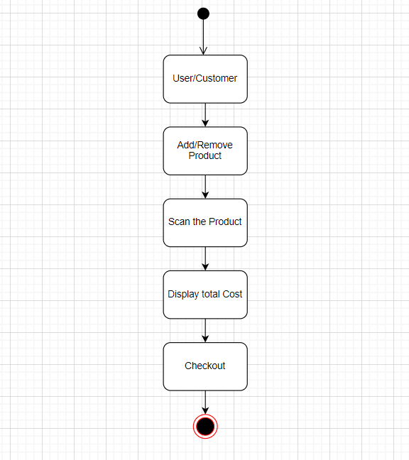

Figure 3.5: Activity Diagram of Supermarket Billing System using

Webcam

# IMPLEMENTATION

##### 4.1 SAMPLE CODE

import tkinter

import cv2

import PIL.Image, PIL.ImageTk from tkinter import simpledialog

import time

from tkinter import messagebox import os

from keras.utils.np_utils import to_categorical import numpy as np

from keras.layers import MaxPooling2D

from keras.layers import Dense, Dropout, Activation, Flatten from keras.layers import Convolution2D

from keras.models import Sequential

from keras.models import model_from_json import pickle

from tkinter import * import random

class App:

global classifier global labels global X_train global Y_train global prices global cart global text global person_id

global img_canvas

global cascPath global faceCascade global pid

def _init_(self, window, window_title, video_source=0): global cart

global text cart = []

self.window = window self.window.title(window_title) self.window.geometry("1300x1200") self.video_source = video_source

self.vid = MyVideoCapture(self.video_source)

self.canvas = tkinter.Canvas(window, width = self.vid.width, height = self.vid.height)

self.canvas.pack()

self.font1 = ('times', 13, 'bold') self.btn_snapshot=tkinter.Button(window, text="Add Product Details", command=self.snapshot) self.btn_snapshot.place(x=10,y=50) self.btn_snapshot.config(font=self.font1) self.btn_train=tkinter.Button(window, text="Train Model", command=self.trainmodel) self.btn_train.place(x=10,y=100) self.btn_train.config(font=self.font1)

self.btn_predict=tkinter.Button(window, text="Add/Remove Product from Basket", command=self.predict) self.btn_predict.place(x=10,y=150) self.btn_predict.config(font=self.font1)

self.btn_person=tkinter.Button(window,

text="Capture Person", command=self.capturePerson) self.btn_person.place(x=10,y=200) self.btn_person.config(font=self.font1)

self.img_canvas = tkinter.Canvas(window, width = 200, height = 200) self.img_canvas.place(x=10,y=250) self.text=Text(window,height=35,width=45) scroll=Scrollbar(self.text) self.text.configure(yscrollcommand=scroll.set) self.text.place(x=1000,y=50)

self.text.config(font=self.font1)

self.cascPath = "haarcascade_frontalface_default.xml" self.faceCascade = cv2.CascadeClassifier(self.cascPath) self.delay = 15

self.update() self.window.mainloop()

def getID(self,name): index = 0

for i in range(len(labels)): if labels[i] == name:

index = i break

return index

def capturePerson(self): option = 0

ret, frame = self.vid.get_frame() img = frame

gray = cv2.cvtColor(frame, cv2.COLOR_BGR2GRAY)

faces = self.faceCascade.detectMultiScale(gray,1.3,5) print("Found {0} faces!".format(len(faces)))

for (x, y, w, h) in faces:

cv2.rectangle(frame, (x, y), (x+w, y+h), (0, 255, 0), 2) img = frame[y:y + h, x:x + w]

img = cv2.resize(img,(500,500)) option = 1

if option == 1:

self.pid = random.randint(1000, 100000) cv2.imwrite("images/"+str(self.pid)+".jpg",img); cv2.imshow("Person ID : "+str(self.pid)+".jpg",img) c2.waitKey(0)

else:

messagebox.showinfo("Face or person not detected", "Face or person not detected")

def snapshot(self):

ret, frame = self.vid.get_frame() if ret:

img = cv2.cvtColor(frame, cv2.COLOR_RGB2BGR)

pname = simpledialog.askstring("Enter Product Name", "Enter Product Name",parent=self.window)

price = simpledialog.askfloat("Enter Product Price", "Enter Product Price", parent=self.window, minvalue=1.0, maxvalue=100000.0) if not os.path.exists('Product/'+pname):

os.makedirs('Product/'+pname)

img_name = time.strftime("%d-%m-%Y-%H-%M-%S") + ".jpg" cv2.imwrite('Product/'+pname+'/'+img_name,img)

f = open("details.txt", "a+") f.write(pname+","+str(price)+","+img_name+"\n") f.close()

messagebox.showinfo("Product details saved","Product details saved")

def trainmodel(self): global labels global X_train global Y_train global classifier global prices labels = [] X_train = [] Y_train = [] prices = []

path = 'Product'

for root, dirs, directory in os.walk(path): for j in range(len(directory)):

name = os.path.basename(root) if name not in labels:

labels.append(name)

for i in range(len(labels)): cost = '0'

with open("details.txt", "r") as file: for line in file:

line = line.strip('\n') line = line.strip() arr = line.split(",")

if arr[0] == labels[i] and cost == '0': cost = arr[1]

file.close() prices.append(cost)

for root, dirs, directory in os.walk(path):

for j in range(len(directory)): name = os.path.basename(root)

img = cv2.imread(root+"/"+directory[j]) img = cv2.resize(img, (256,256)) im2arr = np.array(img)

im2arr = im2arr.reshape(256,256,3) X_train.append(im2arr) Y_train.append(self.getID(name))

X_train = np.asarray(X_train) Y_train = np.asarray(Y_train) print(Y_train)

print(labels) print(prices)

X_train = X_train.astype('float32')

X_train = X_train/255 test = X_train[3] cv2.imshow("aa",test) cv2.waitKey(0)

indices = np.arange(X_train.shape[0]) np.random.shuffle(indices)

X_train = X_train[indices] Y_train = Y_train[indices] Y_train = to_categorical(Y_train)

if os.path.exists('Model/model.json'):

with open('Model/model.json', "r") as json_file: loaded_model_json = json_file.read()

classifier = model_from_json(loaded_model_json) classifier.load_weights("Model/model_weights.h5") classifier._make_predict_function() print(classifier.summary())

f = open('Model/history.pckl', 'rb') data = pickle.load(f)

f.close()

acc = data['accuracy'] accuracy = acc[9] * 100

messagebox.showinfo("Training model accuracy","Training Model Accuracy = "+str(accuracy))

else:

classifier = Sequential() classifier.add(Convolution2D(32, 3, 3, input_shape =

(256, 256, 3), activation = 'relu'))

classifier.add(MaxPooling2D(pool_size = (2, 2)))

classifier.add(Convolution2D(32, 3, 3, activation = 'relu'))

classifier.add(MaxPooling2D(pool_size = (2, 2))) classifier.add(Flatten())

classifier.add(Dense(output_dim = 256, activation = 'relu')) classifier.add(Dense(output_dim = 4, activation = 'softmax')) print(classifier.summary())

classifier.compile(optimizer = 'adam', loss = 'categorical_crossentropy', metrics = ['accuracy']) hist = classifier.fit(X_train, Y_train, batch_size=16, epochs=10, shuffle=True, verbose=2) classifier.save_weights('Model/model_weights.h5') model_json = classifier.to_json()

with open("Model/model.json", "w") as json_file: json_file.write(model_json)

f = open('Model/history.pckl', 'wb') pickle.dump(hist.history, f) f.close()

f = open('Model/history.pckl', 'rb') data = pickle.load(f)

f.close()

acc = data['accuracy'] accuracy = acc[9] * 100

messagebox.showinfo("Training model accuracy","Training Model Accuracy = "+str(accuracy))

def predict(self):

ret, frame = self.vid.get_frame()

img = cv2.cvtColor(frame, cv2.COLOR_RGB2BGR) img = cv2.resize(img, (256,256))

im2arr = np.array(img)

im2arr = im2arr.reshape(1,256,256,3) image = np.asarray(im2arr)

image = image.astype('float32') image = image/255

preds = classifier.predict(image) predict = np.argmax(preds) pname = labels[predict]

print(str(pname)+" "+str(np.amax(preds))) if np.amax(preds) >= 0.85:

cost = prices[predict] if pname in cart:

cart.remove(pname) else:

cart.append(pname) self.text.delete('1.0', END) total_amt = 0

for i in range(len(cart)):

for k in range(len(labels)): if labels[k] == cart[i]:

cost = prices[k]

k = len(labels)

total_amt = total_amt + float(cost) self.text.insert(END,"Product Name : "+cart[i]+"\n") self.text.insert(END,"Product Cost : "+cost+"\n\n")

self.text.insert(END,"Total Amount : "+str(total_amt)+"\n\n") else:

messagebox.showinfo("Unable to recognized product", "Unable to recognized product")

def update(self):

ret, frame = self.vid.get_frame() if ret:

self.photo = PIL.ImageTk.PhotoImage(image = PIL.Image.fromarray(frame))

self.canvas.create_image(0, 0, image = self.photo, anchor = tkinter.NW) self.window.after(self.delay, self.update)

class MyVideoCapture:

def _init_(self, video_source=0):

self.vid = cv2.VideoCapture(video_source) if not self.vid.isOpened():

raise ValueError("Unable to open video source", video_source) self.width = self.vid.get(cv2.CAP_PROP_FRAME_WIDTH) self.height = self.vid.get(cv2.CAP_PROP_FRAME_HEIGHT) self.pid = 0

def get_frame(self):

if self.vid.isOpened():

ret, frame = self.vid.read() if ret:

return (ret, cv2.cvtColor(frame, cv2.COLOR_BGR2RGB))

else:

return (ret, None)

else:

return (ret, None) def _del_(self):

if self.vid.isOpened(): self.vid.release()

App(tkinter.Tk(), "Tkinter and OpenCV")

# SCREENSHOTS

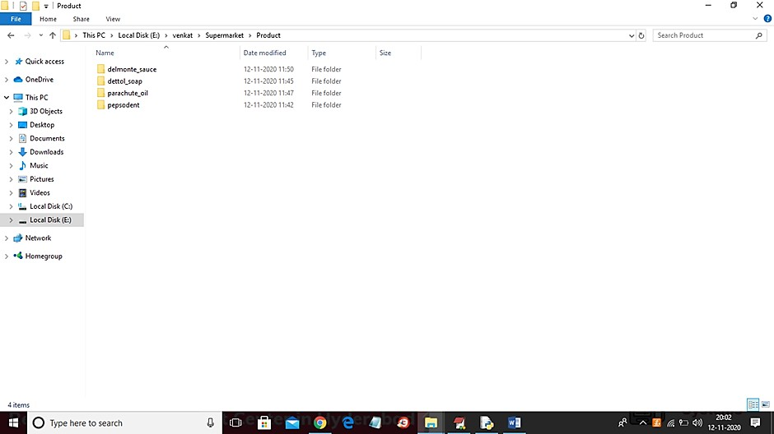

Screenshot 5.1: Product folder is created to store images of the product

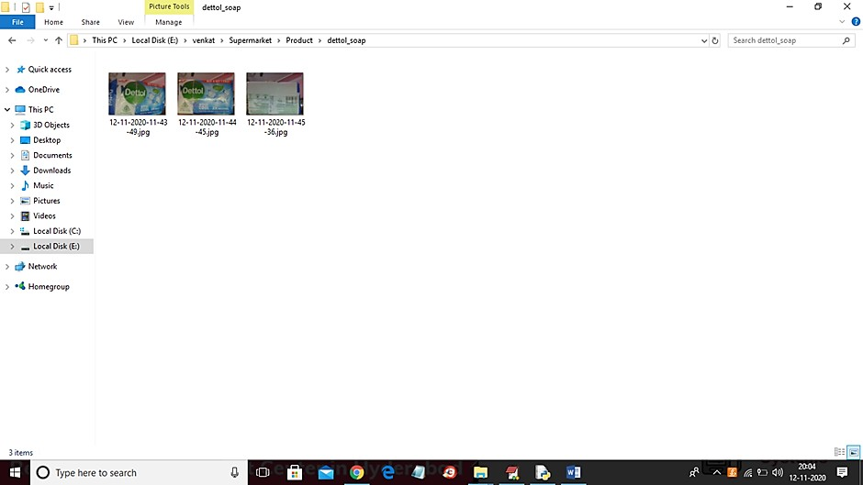

Screenshot 5.2: Front and Back of the Product is Captured and Stored

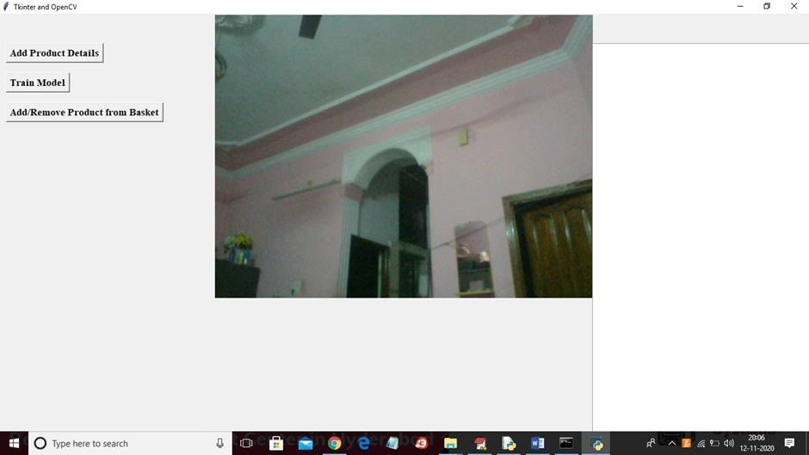

Screenshot 5.3: Applications are connected to webcam and model is trained

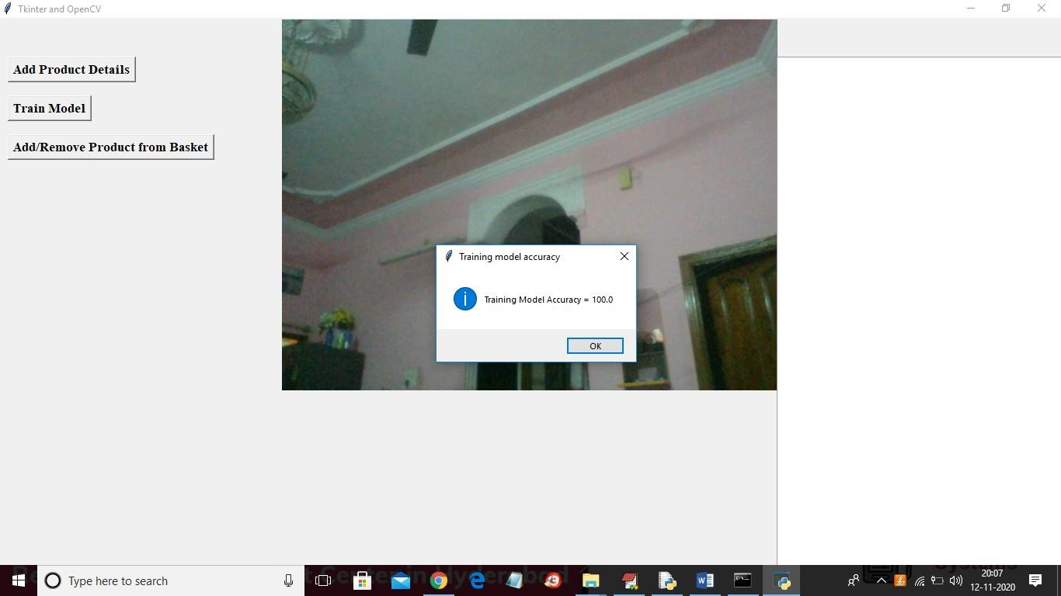

Screenshot 5.4: Accuracy of the trained model is displayed

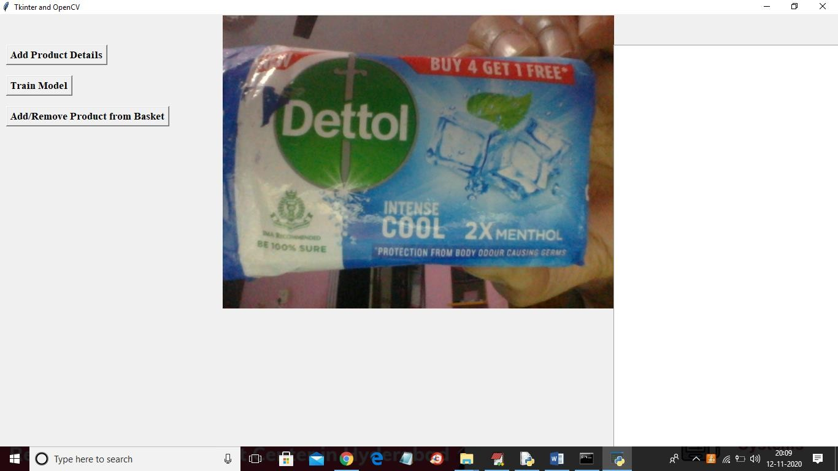

Screenshot 5.5: Product is shown to the webcam

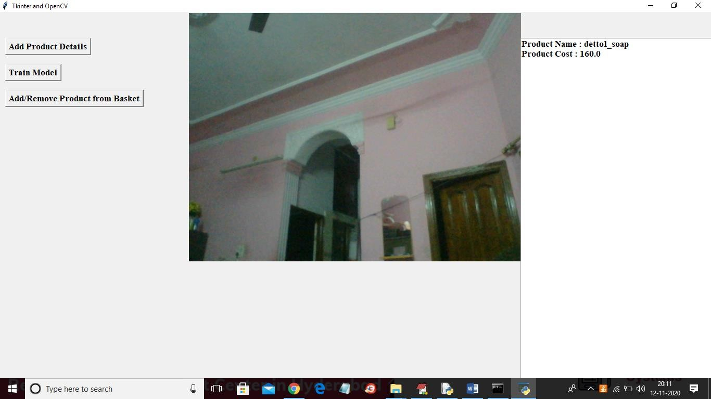

Screenshot 5.6: Product information is displayed

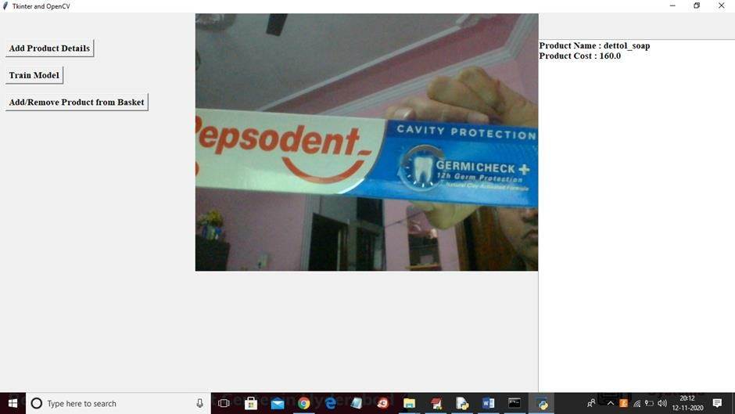

Screenshot 5.7: Showing another product to the Webcam

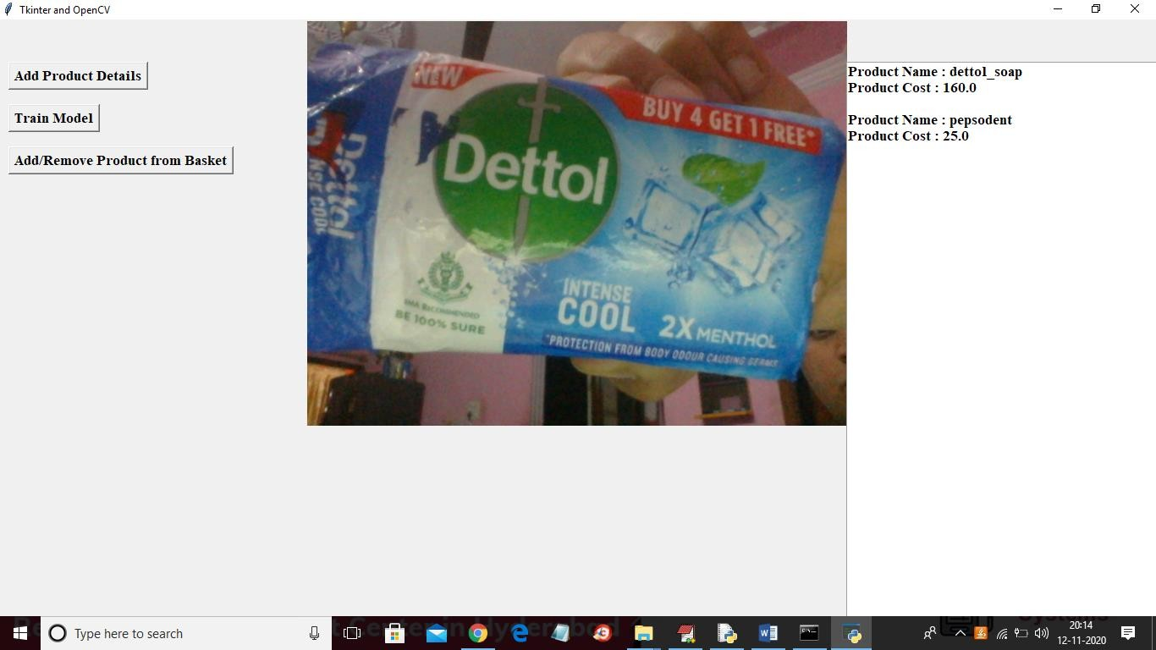

Screenshot 5.8: Product name and cost is displayed for both products

# TESTING

#### TESTING

##### INTRODUCTION TO TESTING

The purpose of testing is to discover errors. Testing is the process of trying to discover every conceivable fault or weakness in a work product. It provides a way to check the functionality of components, subassemblies, assemblies and/or a finished product. It is the process of exercising software with the intent of ensuring that the Software system meets its requirements and user expectations and does not fail in an unacceptable manner. There are various types of tests. Each test type addresses a specific testing requirement.

##### TYPES OF TESTING

###### UNIT TESTING

Unit testing involves the design of test cases that validate that the internal program logic is functioning properly, and that program inputs produce valid outputs. All decision branches and internal code flow should be validated. It is the testing of individual software units of the application. It is done after the completion of an individual unit before integration. This is a structural testing that relies on knowledge of its construction and is invasive. Unit tests perform basic tests at component level and test a specific business process, application and/or system configuration. Unit tests ensure that each unique path of a business process performs accurately to the documented specifications and contains clearly defined inputs and expected results.

###### INTEGRATION TESTING

Integration tests are designed to test integrated software components to determine if they actually run as one program. Integration tests demonstrate that although the components were individually satisfactory, as shown by successfully unit testing, the combination of components is correct and consistent. Integration testing is specifically aimed at exposing the problems that arise from the combination of components.

###### FUNCTIONAL TESTING

Functional tests provide systematic demonstrations that functions tested are available as specified by the business and technical requirements, system documentation, and user manuals.

Functional testing is centered on the following items:

Valid Input : identified classes of valid input must be accepted. Invalid : identified classes of invalid input must Input be rejected.

Functions : identified functions must be exercised.

Output : identified classes of application outputs must be exercised.

Systems/Procedures: interfacing systems or procedures must be invoked. Organization and preparation of functional tests is focused on requirements, key functions, or special test cases.

##### TEST CASES

* + 1. **CLASSIFICATION**

|  |  |  |  |  |  |
| --- | --- | --- | --- | --- | --- |
| Test case  ID | Test case name | Purpose | Input | Output | Test Case  Status |
| 1 | User Registration | To easily access the purchase history | Value must be taken, next page must be displayed. | Value must be taken, next page must be displayed. | Pass |
| 2 | Product Search | Required product is selected | Option must be taken. | Option must be taken. | Pass |
| 3 | Admin Insert | Run the application, products are billed using webcam. | All the  products should be Inserted | All the products should be Inserted | Pass |
| 4 | Bill Payment | To pay the bill | Credit card,debit card,upi,cash are accepted | Credit card,debit card,upi,cash are accepted | Pass |

1. **CONCLUSION**

##### CONCLUSION & FUTURE SCOPE

* 1. **PROJECT CONCLUSION**

Supermarket Billing System using a webcam marks a significant achievement in enhancing the retail experience. This project has successfully streamlined the billing process by implementing webcam-based barcode scanning, thereby reducing errors and improving efficiency. The system's user-friendly interface has made shopping more convenient for both customers and cashiers, and its real-time inventory management capabilities offer better control over stock levels. It represents a promising step towards modernizing supermarket operations and enhancing customer satisfaction in the retail industry.

##### FUTURE SCOPE

The future scope for a supermarket billing system incorporating webcam technology is quite promising. With advancements in computer vision and AI, such a system can offer enhanced efficiency, security, and customer experience. integrating webcams into the billing process can facilitate cashier-less checkout, it improves security by providing real- time surveillance and item tracking. This enhances the shopping experience and encourages loyalty.

## BIBLIOGRAPHY

##### BIBLIOGRAPHY

* 1. **REFERENCES**

1. Atzori, L., Iera, A., & Morabito, G, “The internet of things: A survey,” Computer Networks, vol.54, no. 15, 2010, pp. 2787–2805
2. Gorbunov Vladimir(&) , Ionov Evgen(&) , and Naing Lin Aung \" Automatic Detection & classification of weaving fabric defects based on digital image processing.\" Second International Conference on green computing (2019).
3. Zhang, Yanan, H. Wang, and F. Xu. \"Object detection and recognition of intelligent service robot based on deep learning.\" IEEE International Conference on Cybernetics and Intelligent Systems IEEE, 2018.
4. Oliveira, Bernardo A. G. De, F. Magalhaes, and C. A. P. D. S. Martins. \"Fast and Lightweight Object Detection Network: Detection and recognition on resource constrained devices.\"
5. Gerardus Blokdyk “Object Detection:A Complete Guide” 2020 Edition.

##### GITHUB LINK

###### https://github.com/207r1a05j6/Supermarket-Billing-System-Using-Webcam